**

# Baldivis Secondary College Year 11 2018

# Mathematical Methods Investigation 1

Out of Class Section

**HERON’S RULE**

* *The Out of Class Investigation is designed for you to learn the essentials needed for the In-Class validation.*
* *This is the “Take Home” part of the Investigation. It does not count towards your mark for this investigation.*
* *You will need your Casio Classpad or a spreadsheet.*
* *You are permitted to take this section into the “In Class” validation test to assist you*.

***Date of Validation: Tuesday 27th February***. ***Date of Validation: Wednesday 28th February***.

The rule you have used to calculate the area of a triangle is A = ½bh where b is the length of the base and h is the perpendicular height.

[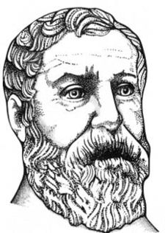](http://en.wikipedia.org/wiki/File:Heron.jpeg)

However outside the school classroom people rarely have the base and the perpendicular height.

They are more likely to be given the lengths of the 3 sides of the triangle. In 60 AD the mathematician Heron of Alexandria published a book with a rule for calculating the area of a triangle and ever since then it has been known as Heron’s rule. It seems however that Archimedes knew the rule over 300 years before Heron!!!

***s is called the semi-perimeter.***

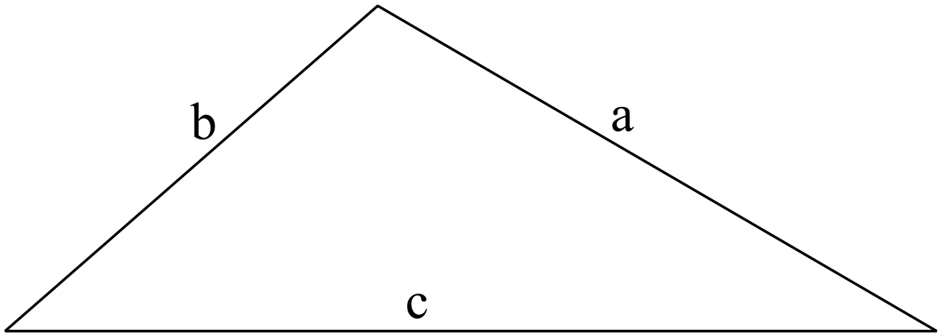



Area = 

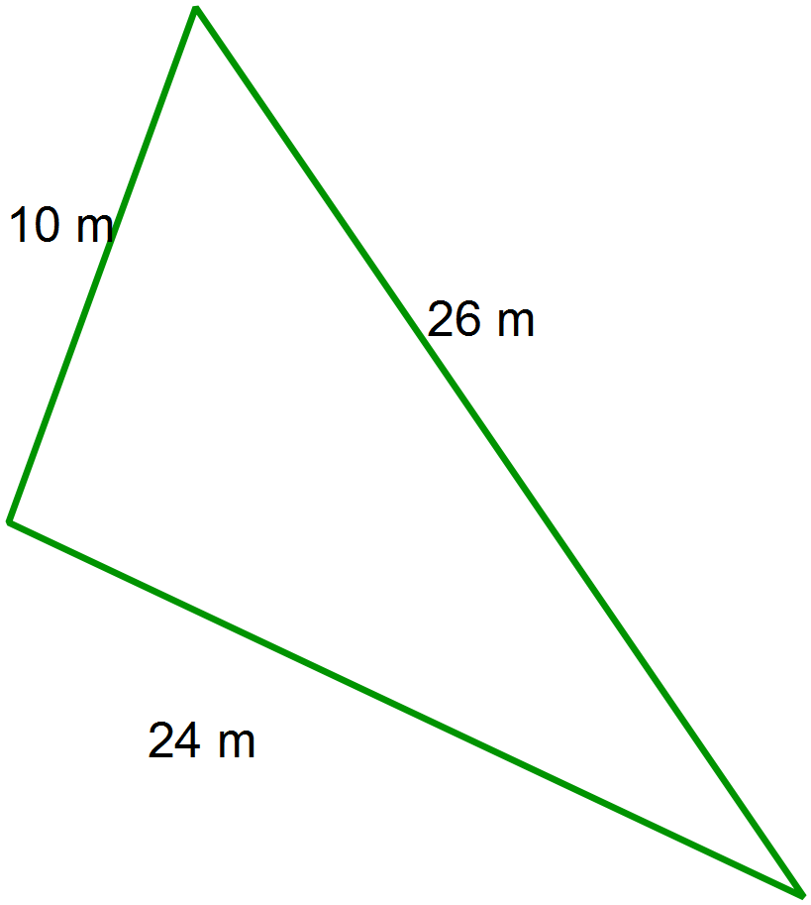

1. Use Heron’s formula to calculate the area

of this scalene triangle shown.

2. Use Pythagoras’ rule to prove that this triangle is right angled.

3. Use this result to show your result the area calculated from from Heron’s Rule is correct.

4. Use Heron’s rule to determine the area



of this isosceles triangle, with a perimeter of 26 cm.

5. Find the perpendicular height of the triangle in question 4.

Show all working.

6. Use another method to determine the area

of this triangle to confirm your solution in

question 4 is correct.

7. Consider the following lengths of the sides of triangles each with a perimeter of 30cm

(semi-perimeter of 15).

***Impossible?***

Find the area of each using Heron’s rule.

***Isosceles triangles?***

(8,10,12) (7,9,14)

***Equilateral?***

(6,11,13) (10,10,10)

***Scalene?***

(9,9,12) (8,8,14)

***Maximum Area?***

(3,10,17) (7,7,16)

***Heron’s rule on NumSolve?***

(4,12,14) (5,11,14)

Try some other triangles of your own with a fixed perimeter of 30 cm.

Show your solutions below.

8. Discuss what you found.

* Which triangles are impossible? Why? What happens to Heron’s rule with these impossible triangles? What relationship must exist between a, b and c for the numbers to form a triangle?
* What type of triangles create the largest area?
* Can you find a rule for the area of the largest triangle in terms of the semi-perimeter,s?

Justify your answer using algebraic steps.

***Amax*** = …………???????

* What are the sides of a triangle with the smallest perimeter possible with a maximum area of 1000 m2? Explain how you found this. What procedure did you use?